Surveying Lab-6 Watershed delineation

**Exercise- Delineate the watershed of the selected river basin**

**Name of the river:YAMUNA RIVER**

**The UTM zone number of the selected river:43N**

**Screen capture of the DEM here (after re-projection)**

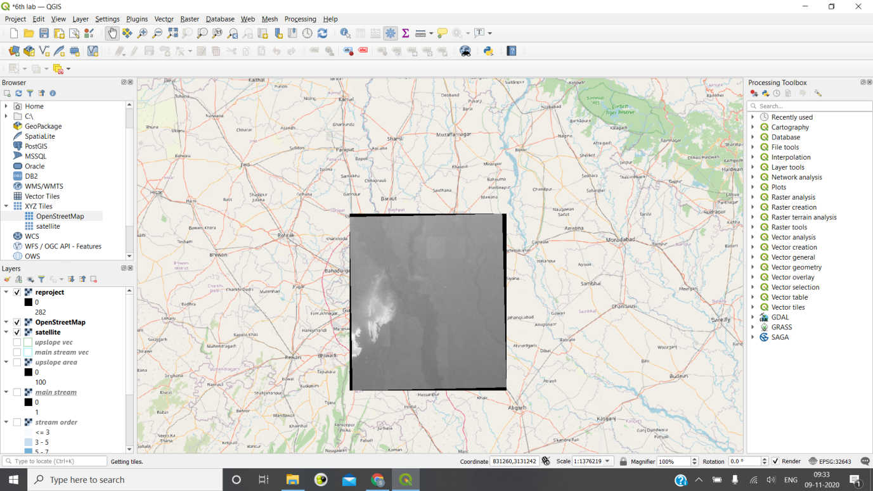

**Screen capture of the Fill sinks**

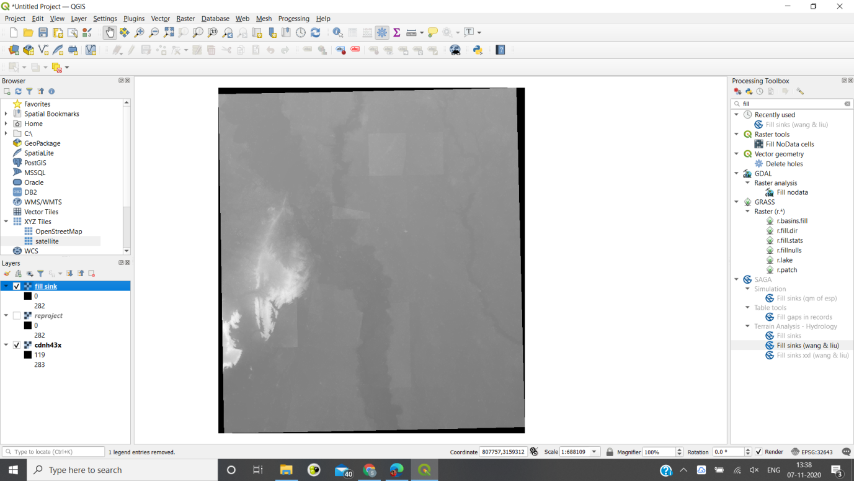

**Screen capture of the Strahler stream order (before raster calculator)**

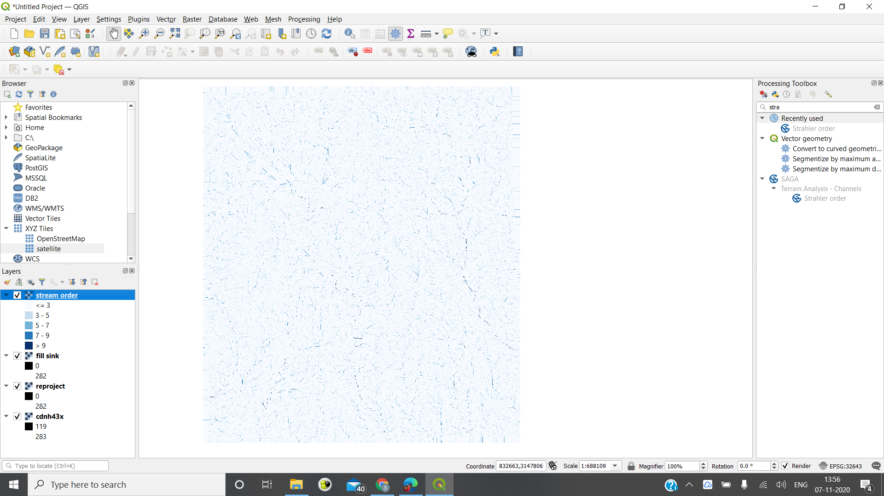

**Write the criteria selected for selecting the stream order**

**Stream order >=7**

**X- Coordinate selected for outlet point: 750660.18 m**

**Y- coordinate selected for outlet point: 3162949.42 m**

**Screen capture of the upslope area:**

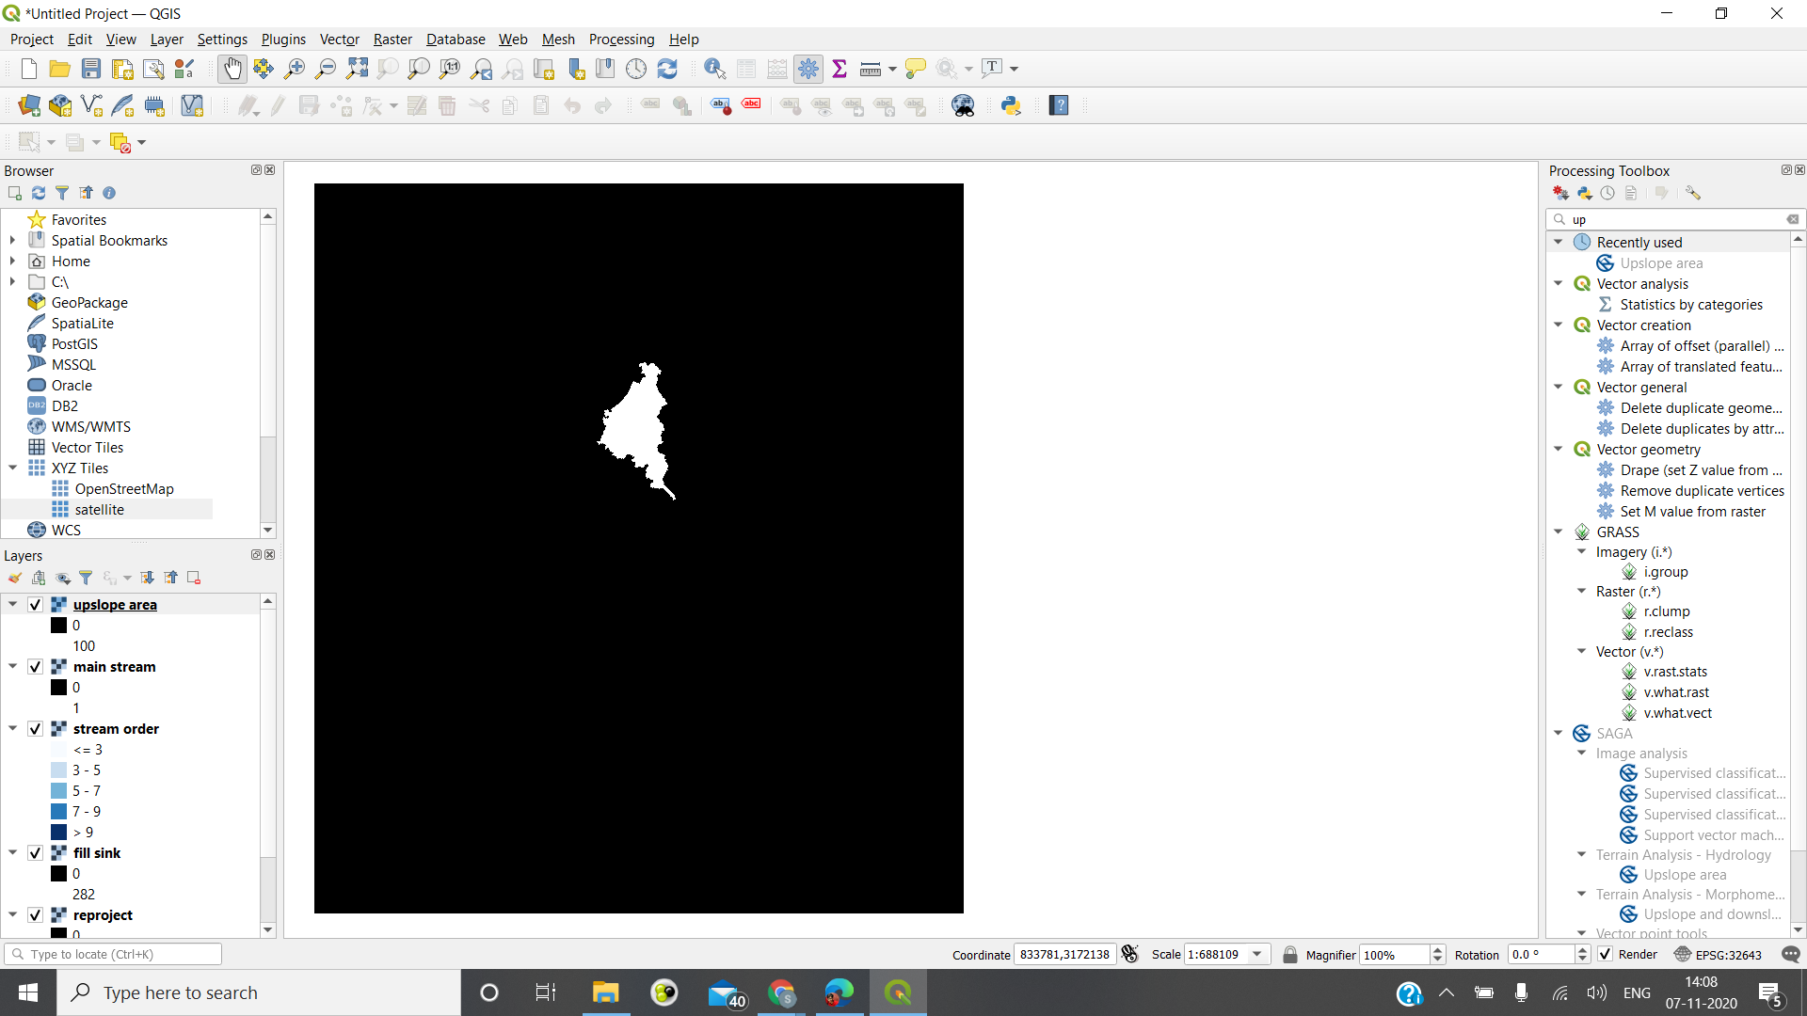

**Screen capture of the polygon showing the upslope area by proper display over the stream network**

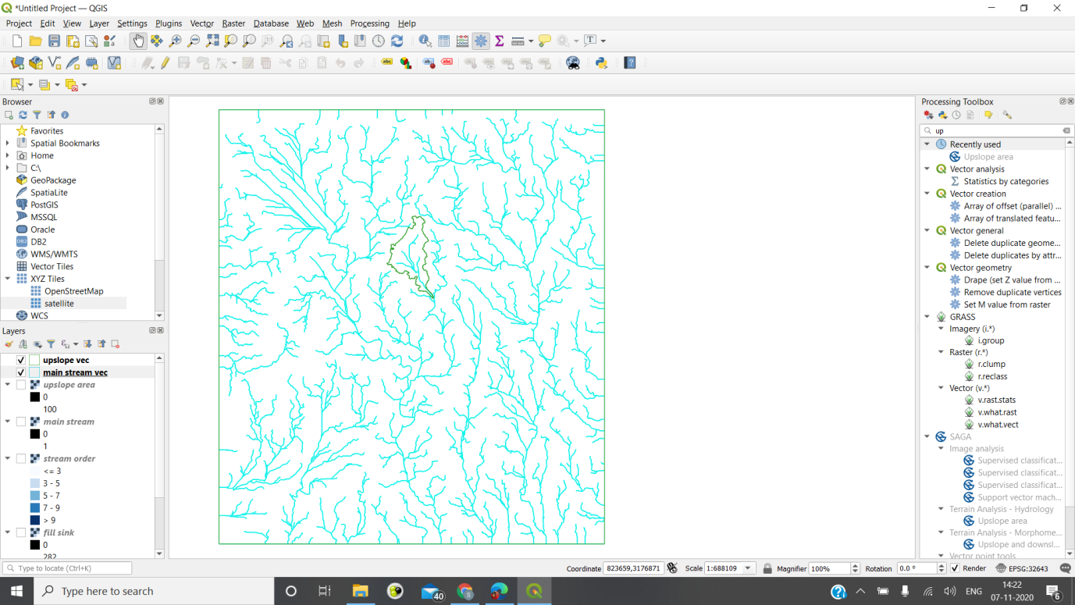

**Area of the watershed (upslope area) delineated in square metres=**

**11,12,79,876 sq metres**